FINALS-LAB 2-INFOE 3
Stephen Gabarda

import random
import csv
from faker import Faker

fake = Faker()

def generate_raw_data(num_entries=30):
raw_data = []
medical_risk_options = ["Low", "Medium", "High"]

for _ in range(num_entries):
entry = {
"name": fake.name(),
"age": random.randint(22, 65),
"zip_code": fake.zipcode()[:5],
"salary": random.randint(40000, 150000),
"medical_risk": random.choice(medical_risk_options)
}
raw_data.append(entry)
return raw_data

def calculate_metrics(data):
salaries = [entry["salary"] for entry in data]
total = sum(salaries)
average = total / len(salaries) if salaries else 0
return total, average

def swap_salaries(data):

salaries = [entry["salary"] for entry in data]

random.shuffle(salaries)

for i, entry in enumerate(data):
entry["salary"] = salaries[i]

return data

def swap_with_safety_check(original_data):

original_salaries = [entry["salary"] for entry in original_data]

swapped_data = swap_salaries(original_data.copy())

same_salary_count = sum(
1 for i, entry in enumerate(swapped_data)
if entry["salary"] == original_salaries[i]
)

while same_salary_count > 0:
swapped_data = swap_salaries(original_data.copy())
same_salary_count = sum(
1 for i, entry in enumerate(swapped_data)
if entry["salary"] == original_salaries[i]
)

return swapped_data

def export_to_csv(data, filename="anonymized_data.csv"):
keys = data[0].keys()
with open(filename, 'w', newline='') as output_file:
dict_writer = csv.DictWriter(output_file, fieldnames=keys)
dict_writer.writeheader()
dict_writer.writerows(data)
print(f"✅ Exported to {filename}")

if __name__ == "__main__":
print("🔹 Generating raw dataset...")
raw_data = generate_raw_data(30)

pre_total, pre_avg = calculate_metrics(raw_data)
print(f"\n📊 Pre-Swap Metrics:")
print(f" Total Payroll: ${pre_total:,.2f}")
print(f" Average Salary: ${pre_avg:,.2f}")

print("\n🔄 Swapping salaries...")
anonymized_data = swap_with_safety_check(raw_data)

post_total, post_avg = calculate_metrics(anonymized_data)
print(f"\n📊 Post-Swap Metrics:")
print(f" Total Payroll: ${post_total:,.2f}")
print(f" Average Salary: ${post_avg:,.2f}")

print("\n🔍 Integrity Check:")
print(f" Total Match: {'✅' if pre_total == post_total else '❌'}")
print(f" Average Match: {'✅' if pre_avg == post_avg else '❌'}")

export_to_csv(anonymized_data, "anonymized_hr_data.csv")

print("\n📋 Preview of anonymized data (first 3 rows):")
for i in range(min(3, len(anonymized_data))):
print(anonymized_data[i])
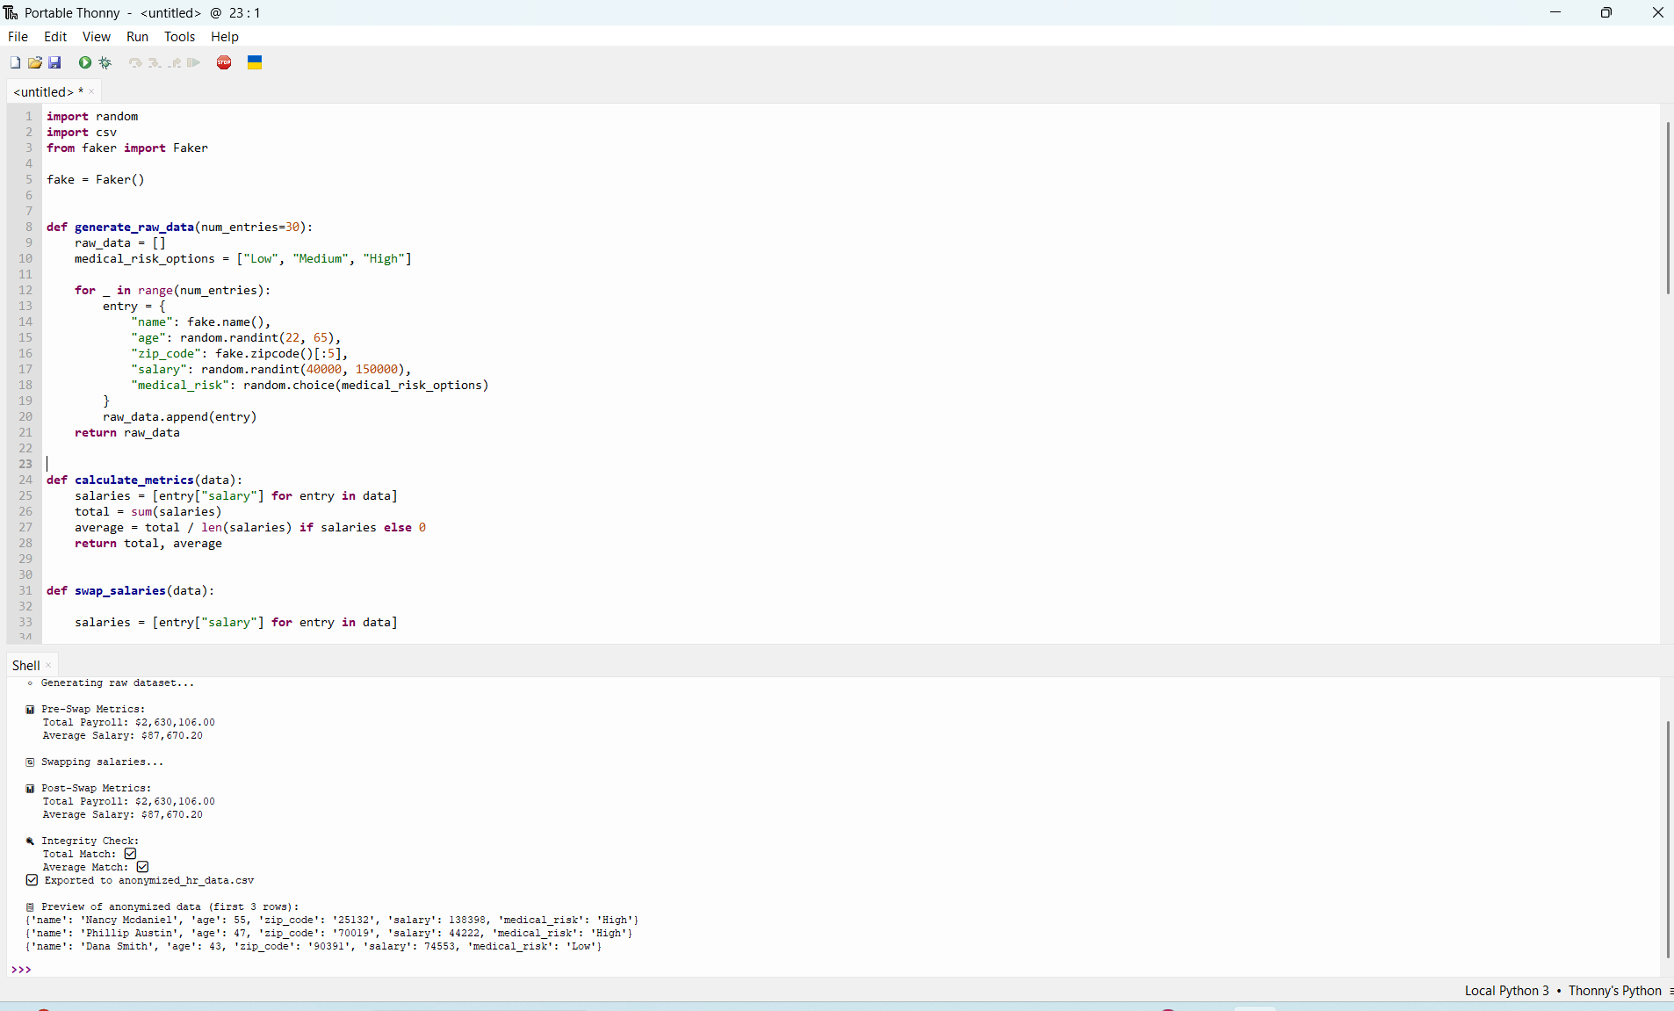

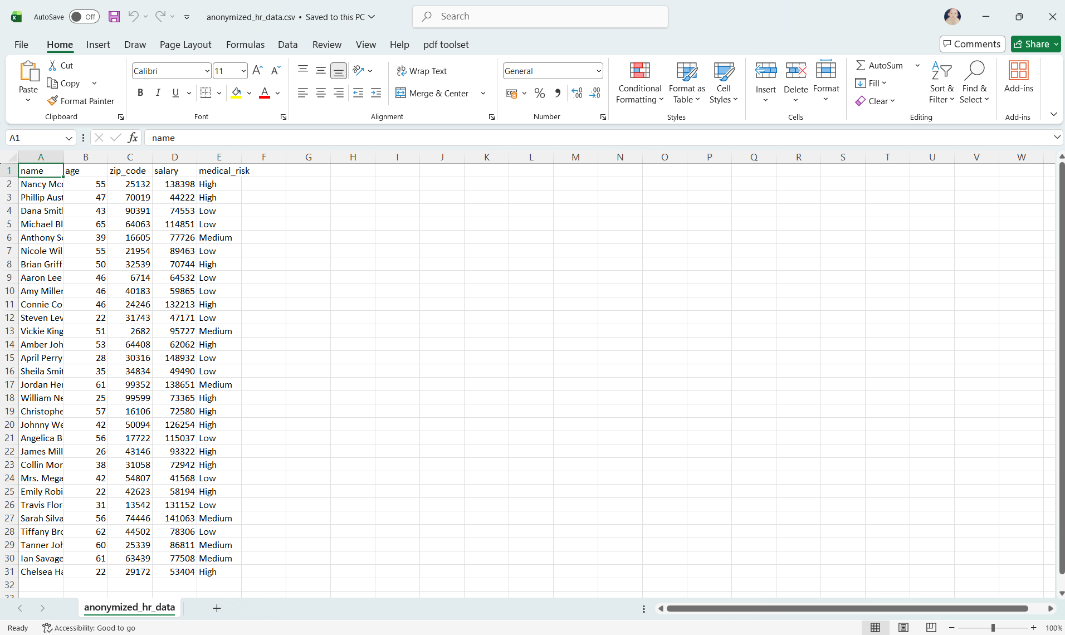

Objective
Decouple names from salaries to prevent individual identification while preserving total payroll and average salary for statistical auditing.
Step | Description
Load Data | Generate 30+ synthetic employee records using Faker
Pre-Swap Metrics | Calculate total salary sum & average
Perform Swap | Extract salaries → shuffle → re-inject
Integrity Check | Verify totals match post-swap
Export | Save anonymized dataset to CSV

